1.Read the data from s_HREMPLOYEES table and load the data in newly created tanle in SQL server database.

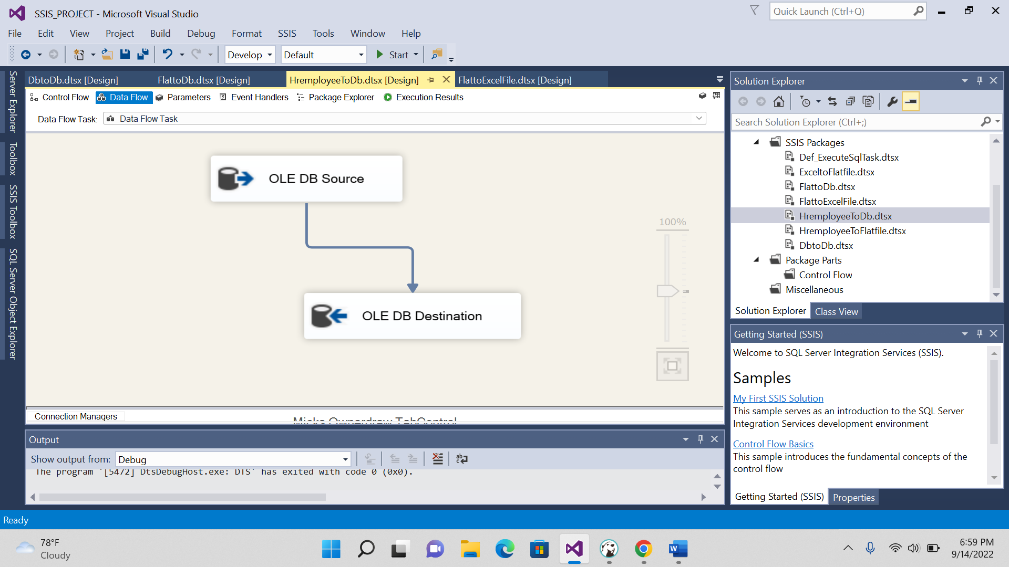

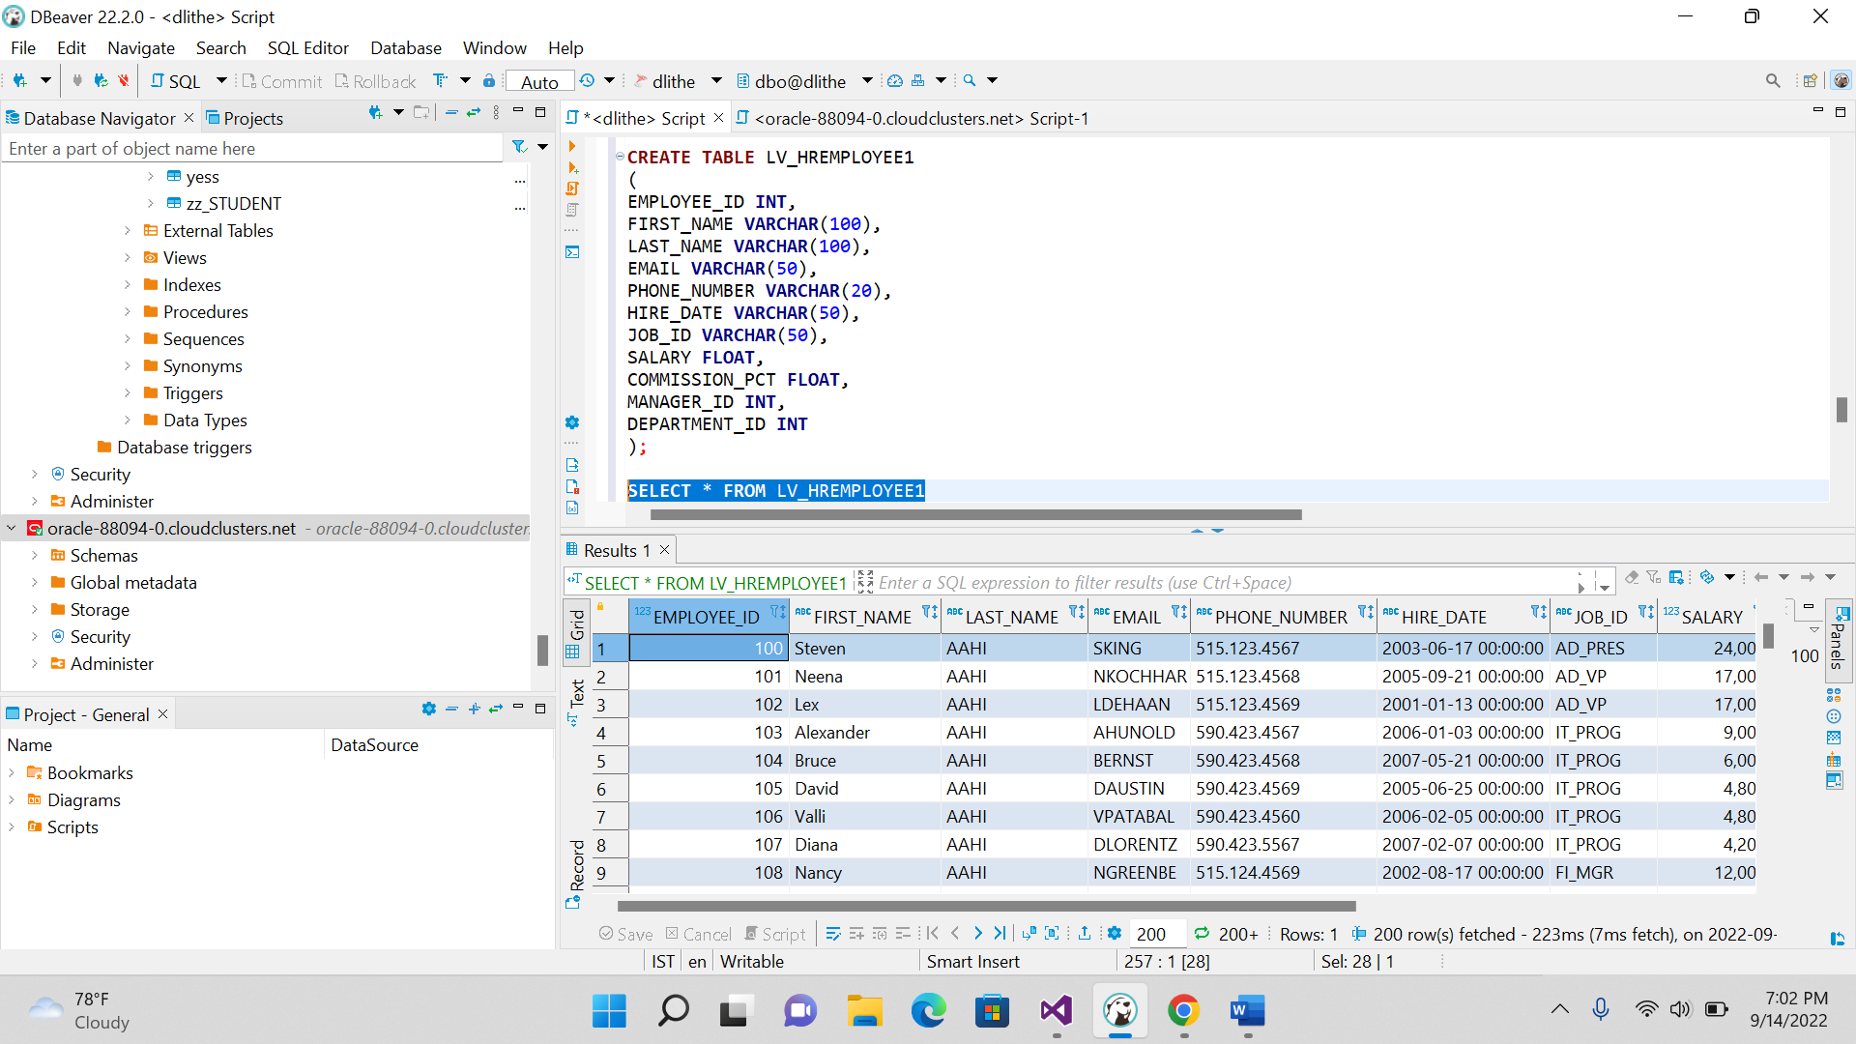

2.Read the data from s_HREMPLOYEES table and load the data flat file.

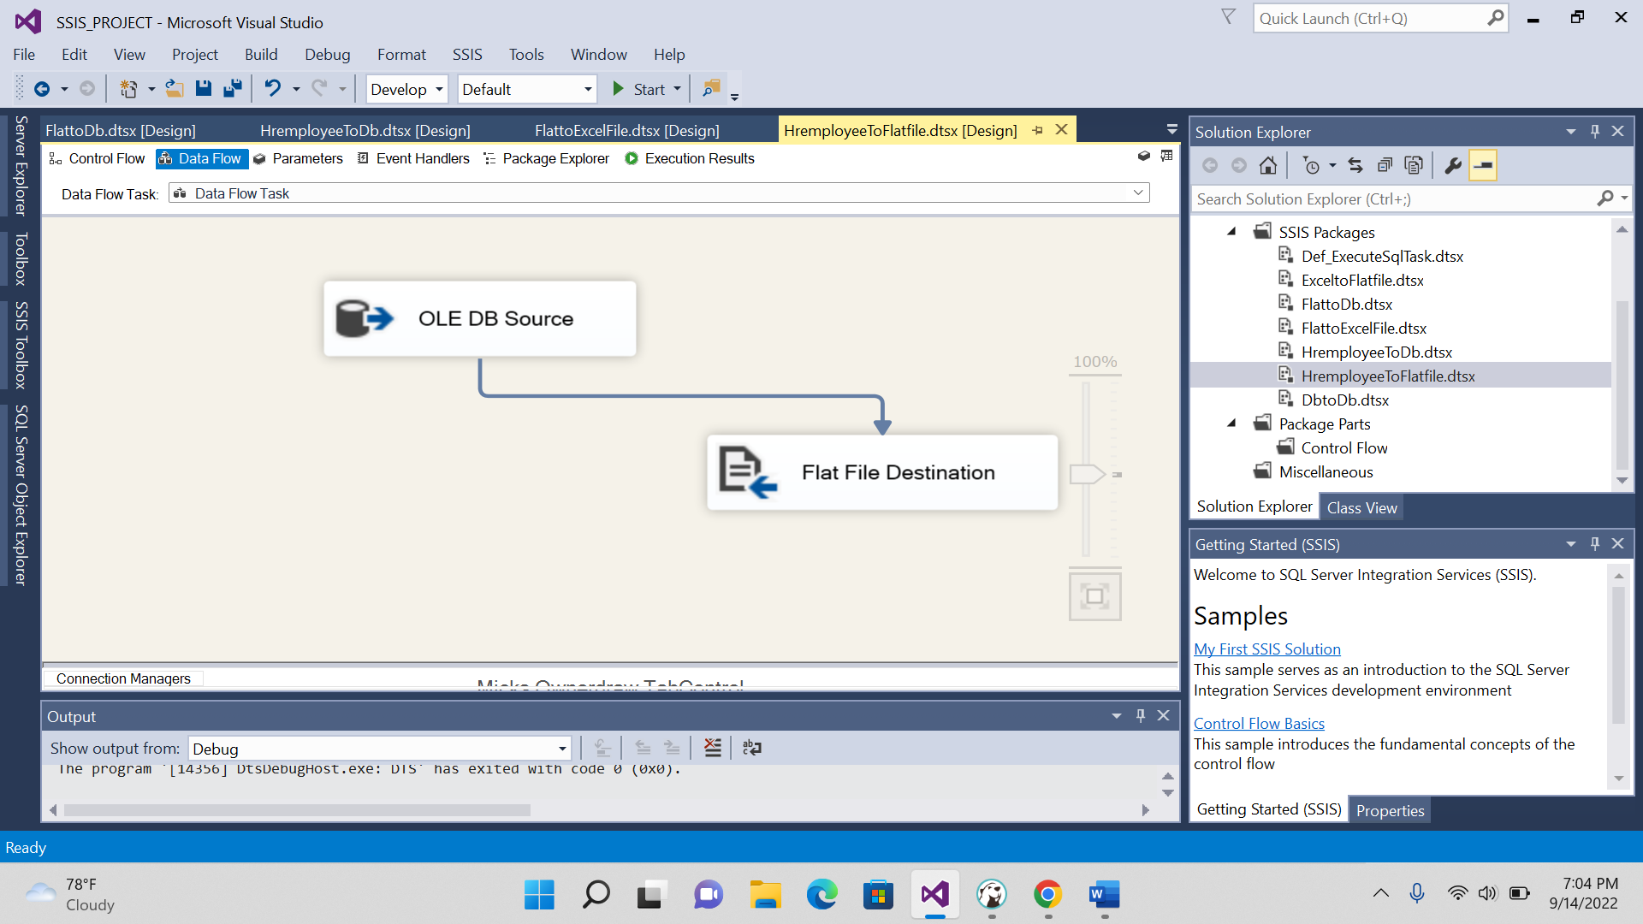

3.Read the data from Flat file and load the data in newly created table in sql server database.

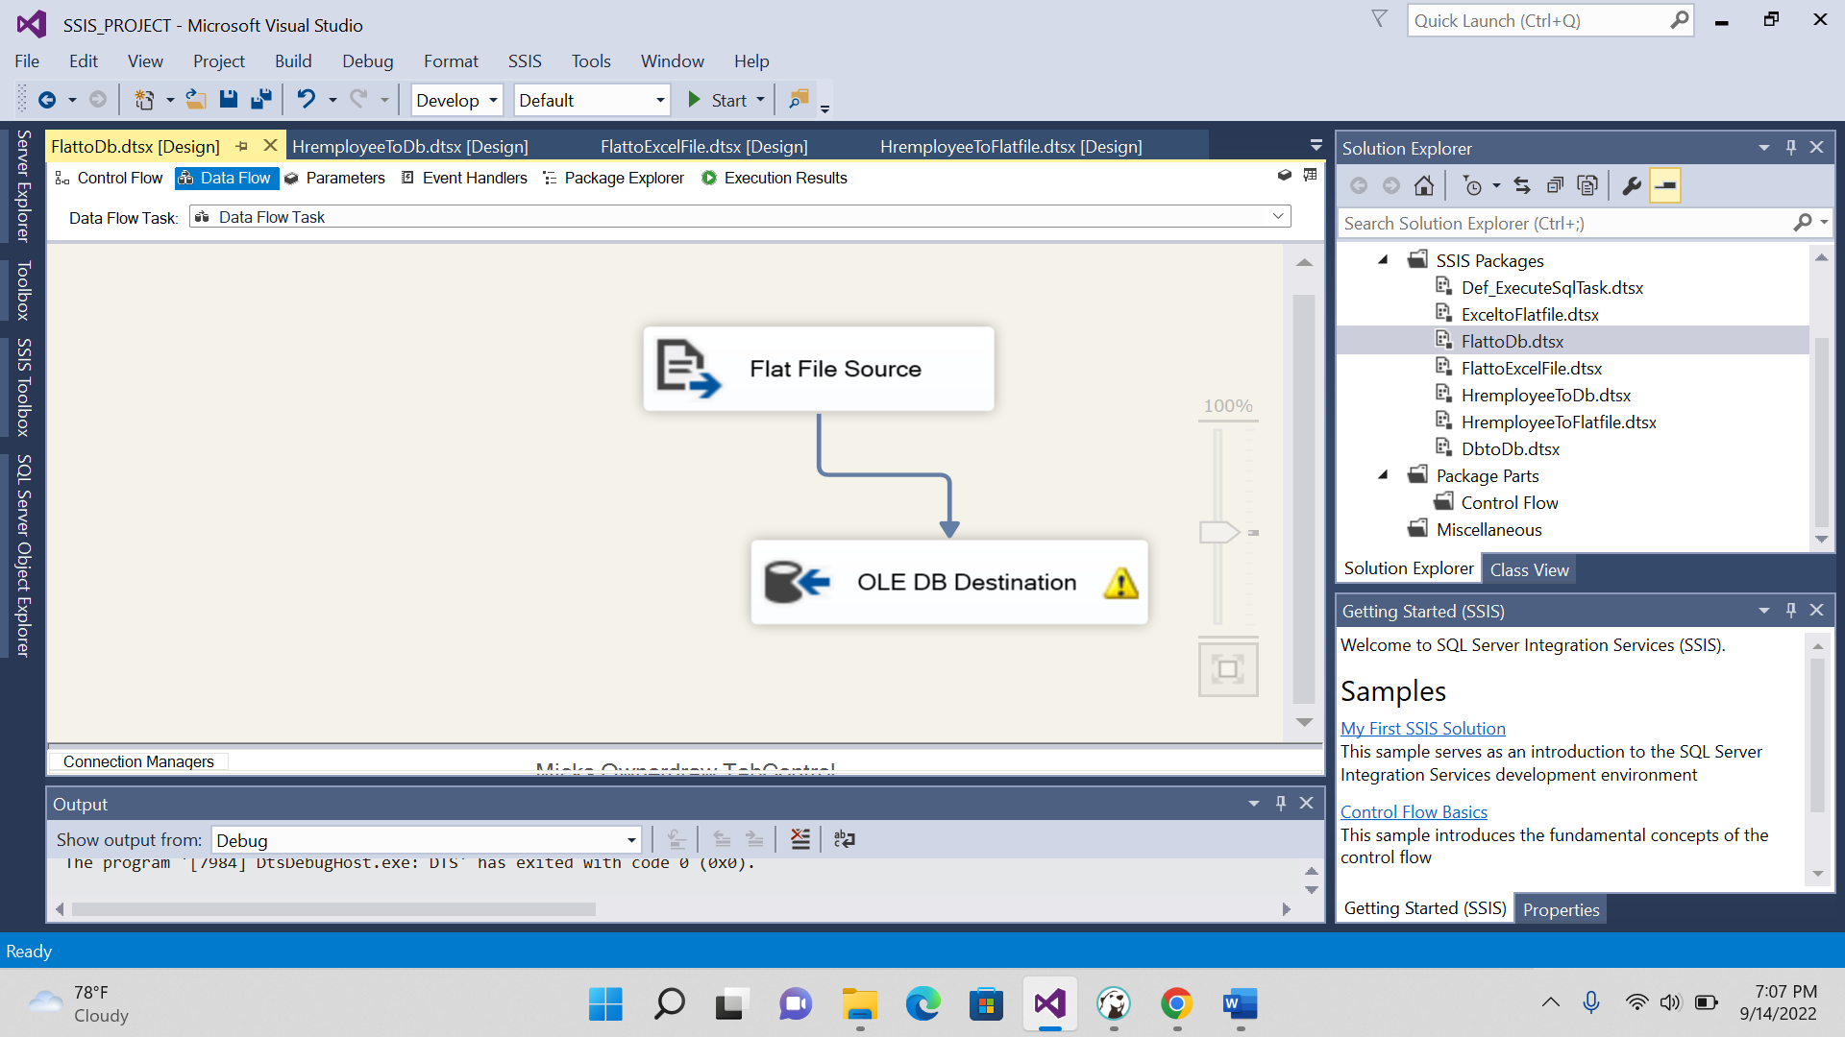

4. Read the data from flat file and load the data flat file.



